RESUME

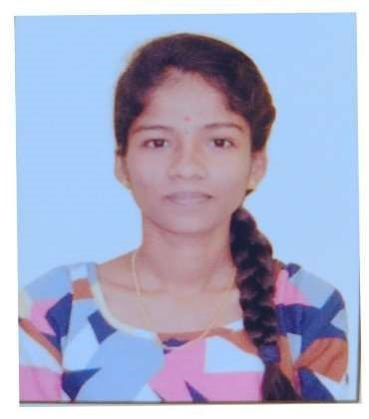

Name : Ankita I Naik

Address : Hosahittala, Manki

TQ: Honnavar, Uttara Kannada.

581348

Mob : 7483599065

Email ID : naikankita752005@gmail.com

CAREER OBJECTIVES

To secure a challenging position in a reputable organization to expand my learnings, knowledge and skills. Responsible position that will impact company’s development and enrich professional skills.

EDUCATIONAL QUALIFICATION

TECHANICAL EDUCATION [Lateral Entry]:-

|  |  |  |  |  |
| --- | --- | --- | --- | --- |
| COURSE | UNIVERSITY | SEMESTER | SGPA | PERCENTAGE |
| Diploma in  Electronics and communication engineering | Shree  Vidyadhiraj  Polytechnic  Kumta | III    IV | 7.62    8.08 | 68.70%    71% |

|  |  |  |  |
| --- | --- | --- | --- |
| COURSE | SCHOOL/COLLEGE | YEAR OF  PASSING | PERCENTAGE |
| PUC | Govt Mohan K  Shetty PU College  Honnavar | 2023 | 65.83% |
| SSLC | Janata Vidyalaya Murdeshwar |  |  |

EXPERIENCE

• Fresher

ONLINE COURSES & CERTIFICATES

* Kalman Filter in Autonomous Vehicle Technologies.
* Basic of Electric Vehicle.
* Self-Charged Hybrid Electric Vehicle.
* Introduction of EV charging.
* Electric Vehicle Service Lead Technician.

STRENGTH

* Self confidence and self learning.
* Team work.
* Managing ability.

SKILLS

* Basic Knowledge of Computer.
* PCB Designing.
* Multisim.
* MS Word.
* C Programming.
* Matlab.
* Troubleshooting.

PERSONAL INFORMATION

Father Name : Irayya S Naik.

Mother Name : Sushila I Naik.

Date Of Birth : 07/05/2005

Gender : Female

Nationality : Indian

Religion : Hindu

Language known : Kannada, English

# DECLARATION

I hereby declare that all the details furnished above are true to the best of my knowledge and belief.

Place: Honnavar Your’s Faithfully,

Ankita